**Third Project Submission Group 13 Proj 1**

The aim of this submission is to understand and implement the first four phases of the *Double Diamond Model*, i.e., Discover, Define, Develop and Deliver.

* Refined [Requirement gathering, Persona, Problem Understanding, Low Fi Design] [1 marks]
* High-Fidelity Design with some evaluation [4 marks]– creating functional and interactive prototypes on Figma and evaluating the product by user testing it along with documenting the user evaluation.

**REFINED:**

**Requirement Gathering:**

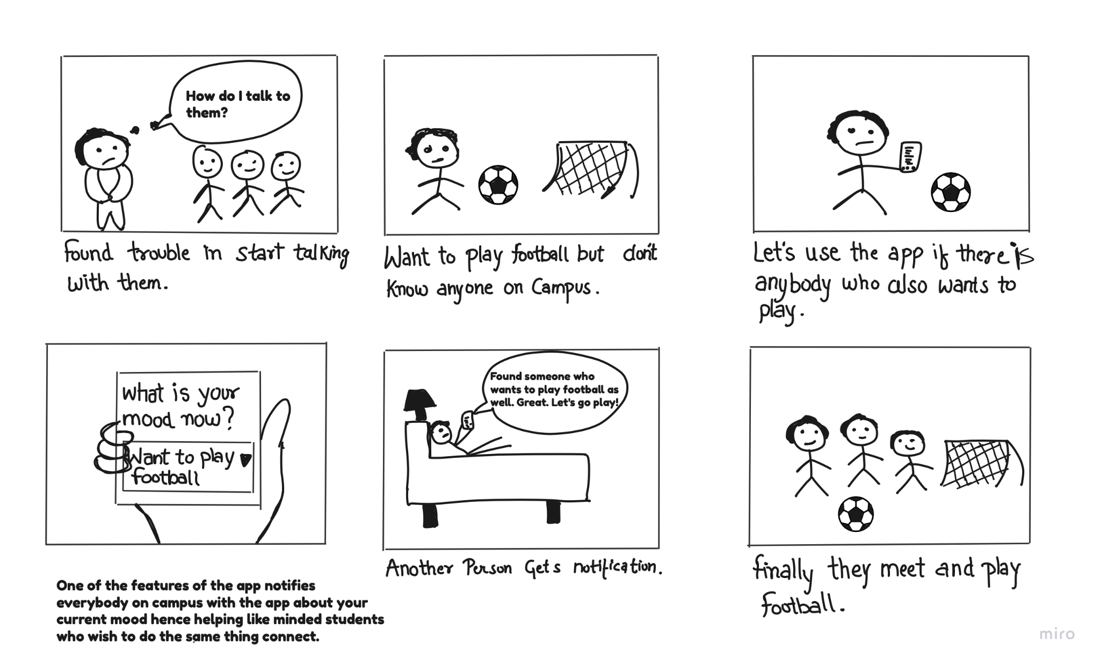

This is an example of a storyboard that depicts our app's functionality and purpose.

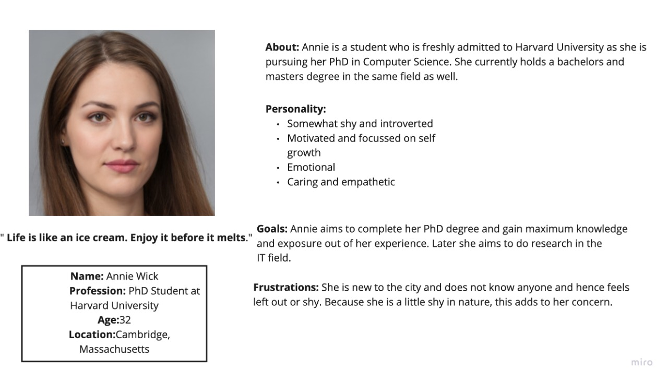

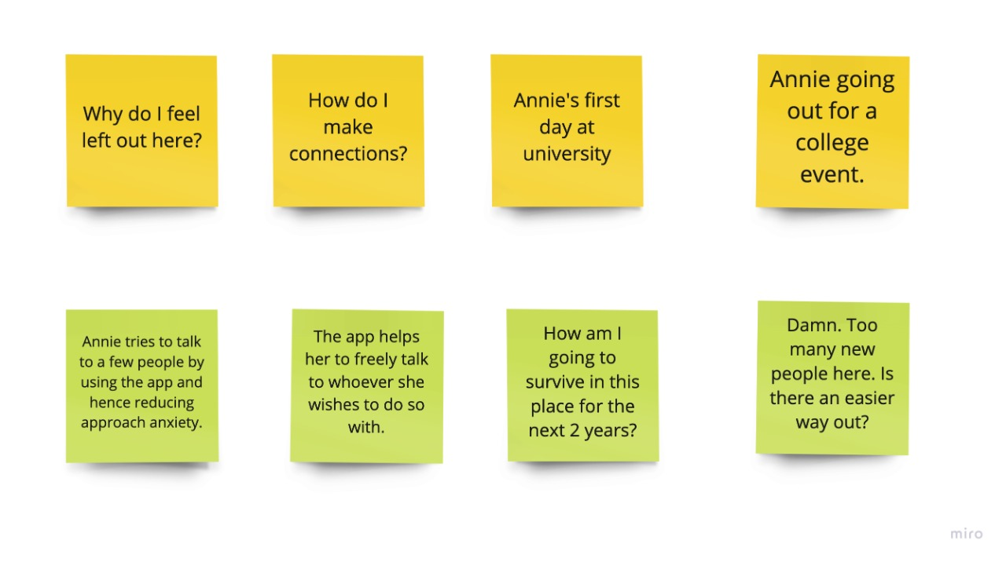

The following is an example of a persona and the scenario of the possible use of our app.

**Problem Understanding:**

According to a survey conducted by an established journal, the fear of being judged has grown to be one of the biggest fears in emerging times. We all have stories of how we felt scared/anxious while approaching someone new and talking to them. Oftentimes, we have this urge to talk to people we see around. It can be varying from anything as the urge to ask the person’s name and have a conversation with them, or it’s as tiny as just complimenting someone. However, something inside us holds us back from openly doing so. Even on the rare occasions you do, how much mental stress and fighting against all the thoughts have you done to do this little task?

In today’s day and age, communication and conveying our thoughts are of utmost importance. And if a thing as necessary as this cannot be executed without us having to beat ourselves up and make it a mountain of a task, it’s time to find something that helps us.

Through this project, we aim to do precisely this. We aim to connect person A to a random stranger, person B, whom A wants to talk to through a radar-based notification system in which person B will be notified that someone wishes to speak to him. In this way, person A can take some initiative to approach B. As the world revolves around connections, most likely, person B will acknowledge person A’s wish to talk to him, and that can make all of the difference in A opening up to B and possibly forming a connection for life.

**Lofi Design:**

This is one model of the app that we had created as the Lofi Design.

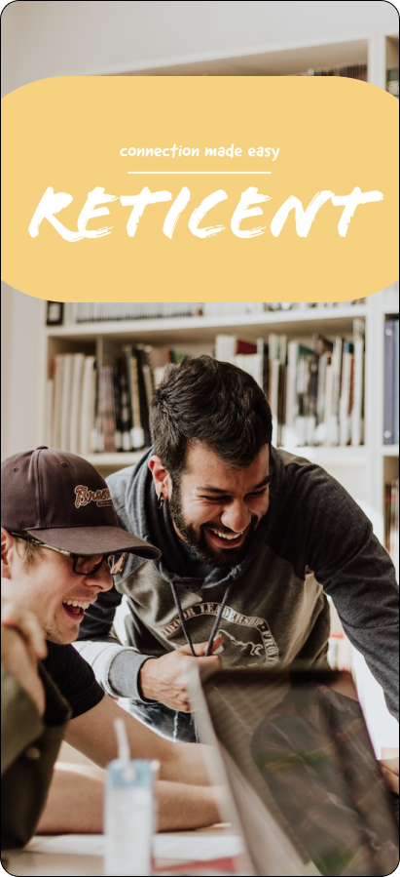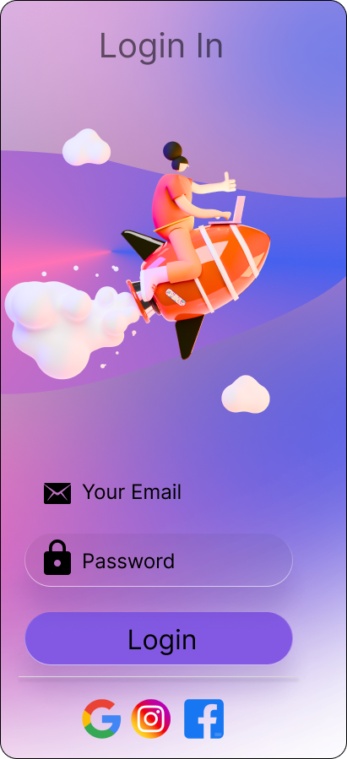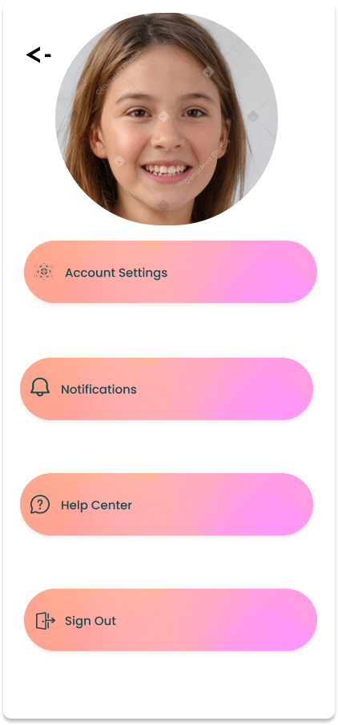

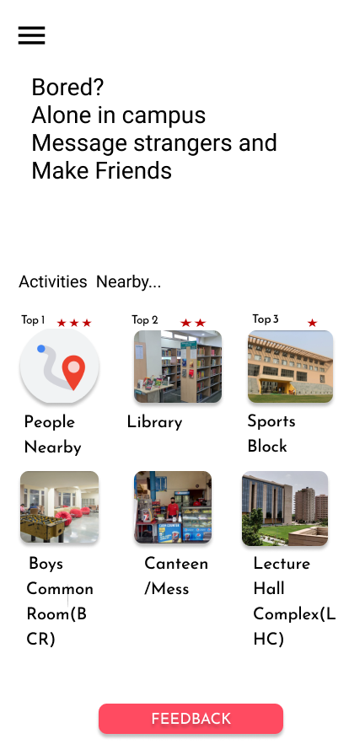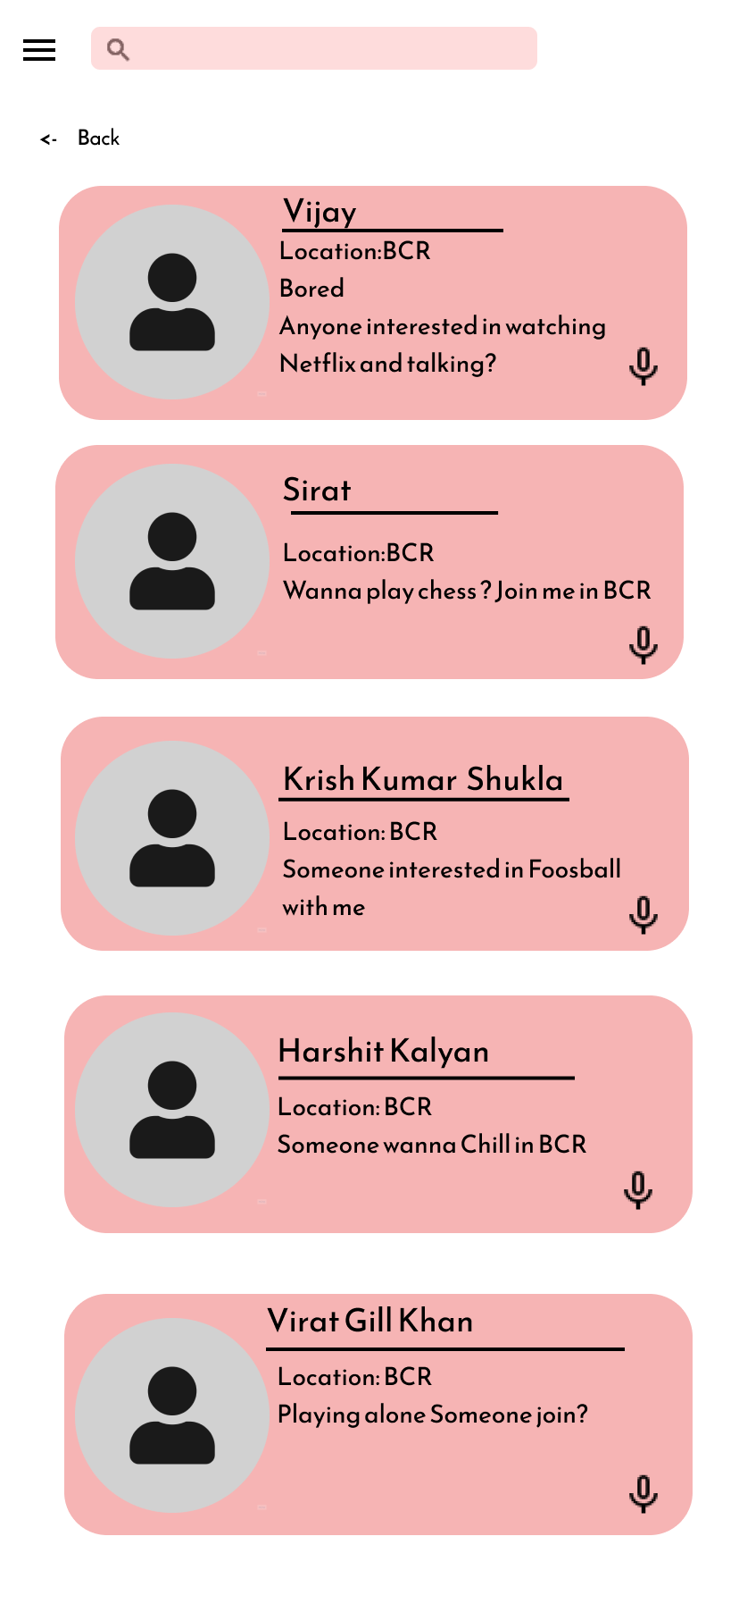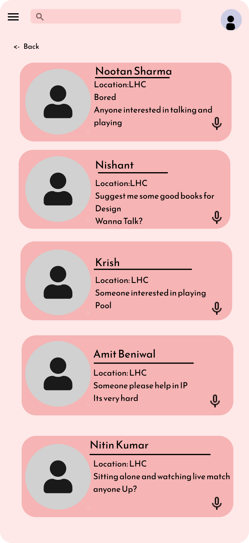

**High-Fidelity Design with some evaluation :**

**The link for the same:**

[**https://www.figma.com/file/1vpFQtFSBtARYMQJ2HjBcJ/high-fidelity-prototype-(Community)?node-id=0%3A1&t=G6G8zSRCfwNnvqvy-1**](https://www.figma.com/file/1vpFQtFSBtARYMQJ2HjBcJ/high-fidelity-prototype-(Community)?node-id=0%3A1&t=G6G8zSRCfwNnvqvy-1)

**Click the link to check the FULL design prototype that we have created after user testing and evaluation.**

**Check the link above for the FULL prototype.**

**User Evaluation:**

As a part of the user evaluation process, we have taken feedback from several of our batchmates, seniors and friends.

For the most part, the response to this prototype that we have created has been very positive.

The users are finding our product to have the right kind of utility as well as being easy to use and efficient at the same time. A few users have also appreciated the fact that we have kept a feedback page in our prototype by which we can regularly keep up with the demands of users based on the user feedback.

We also got positive feedback on one of the central themes of the project which is a radar based notification system which helps people connect.

Another common feedback was that the onboarding process was smooth and simple.

Based on the feedback and user evaluation we have gone ahead with this prototype for our project.

**Credits and Contribution:**

**Krish Kumar Bhoruka:2022253**

Attended all the meetings. Made most of the Hi-Fi design and did most of the wiring for the prototype.

**Krishna Shukla: 2022254**

Organized and attended all meetings. Helped in the Hi-fi design, prototyping and wiring.

**Krishnendu: 2022255**

Attended all the meetings. Helped in the Hi-fi design, prototyping and wiring.

**Kshitij: 2022256**

Attended all the meetings. Helped in the Hi-fi design, prototyping and wiring.

**Kshitij Gupta:2022257**

Attended all the meetings. Helped in the Hi-fi design and did the documentation.